**General Introduction.**

The safety of children has become a major concern for many parents in recent years, and this has caused them to worry much about their children's safety on school buses. They are constantly concerned about the arrival time of their children's bus for pick-up and drop-off. Have children boarded the bus? Where is the bus taking their kids? Is the arrival of the kids delayed in any way?

  School Bus Tracking Management System, is a mobile and web-based tool that tracks the location of school buses and gives administrators, parents, and drivers real-time updates using GPS technology and software programs. Administrators may more easily manage their transportation resources while parents are able to know exactly when their child's bus will arrive at home. The system also notifies users of any schedule modifications or delays.

The School Bus Tracking Management System is crucial because it assures parents and the school that their children are safe because it tracks their movement to and from the school, also It gives the school administration team the best route for minimum fuel consumption. Furthermore, School bus tracking systems passes notifications to both the parties about any divergence from the route or any unusual behavior example no movement due to breakdown. Such real time updates allow schools to take relevant actions at their end.

Conclusively, School Bus Tracking Management System is of a great importance to parents, administration team and drivers since it monitors the entire school commute and intimates the parents about important notifications.

**Statement of the Problem**

The system addresses the problem faced by parents to wait for long duration of time for the arrival of the bus. It also addresses the problem related to child abduction which is increasing day by day. Here we are using mobile phone to track the location of the bus and thereby calculate the estimated time required by the bus to reach the destination. It is necessary to have such device to track the bus, especially the school bus as most of the children travel by bus to school which is the most convenient transport. In order to reduce the waiting time by parents and children on the bus stop the parent side android device is used to send the current location of the parent and receive the expected arrival time.

Furthermore, the system describes the problem faced by school bus drivers when they incur fuel consumption costs, especially when they go to pick up students who cannot attend school for various reasons, and it also describes the challenges that new drivers go through because they are not familiar with student’s pick-up stations.

**Objective**

**Main Objective.**

To develop School Bus Tracking Management System which will Keep parents directly informed and notified easy about the movements of their children from home to schools and way back home, whilst allowing schools to manage and control emergency situations efficiently. Allow a driver to privately notify school administrator of emergency events directly through customized push notifications such as car breakdown emergency.

**Specific Objectives.**

1. To conduct a survey to identify the need for School Bus Tracking Management System.
2. To gather requirements for the School Bus Tracking Management System from stake holders
3. To design School Bus Tracking Management System from the gathered requirements.
4. To implement the design of the system

**Significance of the project**

1. The system helps to reduce time the waiting time of parents and students waiting for the school bus.
2. The system helps the school administration to keep track and monitor the route of the school buses
3. The system acts as a directive to new drivers to know pickup points of the students
4. The system gives notification to the parents and school administration about any emergency that has occurred.
5. The system helps to suggest the best route for minimum fuel consumption to drivers

**Project scope**

The scope of this project is based on nursery and primary school students, parents, school administration and school bus drivers in tracking the school buses and getting real-time information about them. The administrator module is concerned with all administration details, The parent module is concerned with the management of the student details in regards to the school bus assigned to his child, while the driver module is based on the details regarding the real-time information about the vehicle. The system database will capture the student details, driver details and the vehicle details.

**Organization of the project**

|  |  |
| --- | --- |
|  |  |
|  |  |
|  |  |
|  |  |
|  |  |
|  |  |
|  |  |

**Chapter 2**

**Literature review**

**2.1 overview**

A literature review involves the process of survey of the major writings and other sources that provides an overview of a selected topic .This chapter consists of different reviews on the concept of this project topic.

2.2 Existing solutions

2.2.1 Bustracker

Bustracker is a mobile and web based application which focuses on providing parents/guardians with information about the school buses boarded by their children.

The literature review was undertaken how this system works .This system helps to track school buses from the parent’s mobile phones and receive all real-time information about the school bus, it also offers additional functionalities such as emergency management, and push notifications .

2.2.2 Schoolbus

Schoolbus is a mobile based application where parents and guardians track their children’s school buses via SMS and Mobile application. This application has two modules which are driver module and the parent module, it mainly facilitates the communication between the parent and the bus driver.

2.3 Project Gap

Some core and basic functionalities such as GPS tracking of school buses , Vehicle information management ,Mobile alerts , Route management that exist in the current systems will be reused and modified in our system.

Our system will also add other functionalities such as suggesting best route for the driver, student emergency management, Pick / drop SMS, improve user experience as some existing system are not user friendly, by improving user experience it helps to fulfill the user’s need in a smooth way.

In addition, the registration of driver’s assistants (conductors) in the system will be included, their contact, names, and location.

# CHAPTER THREE

# METHODOLOGY

## **3.1 Overview**

Methodology is a formalized approach to implementing the system development life cycle (SLDC) i.e., is the list of steps and deliverables. In this project the software development methodology that is going to be used is Agile Methodology.

## **3.2 Agile Methodology**

Agile development is a group of programming-centric methodologies that focus on streamline the SDLC. This methodology eliminates much of the modeling and documentation overhead it prefers face to face communication. A project emphasizes simple, iterative application development on which every iterative is a complete software project, including planning, requirement analysis, design, coding, testing and documentation. this means that it can be modified whenever there is a faulty component, or reorganized.

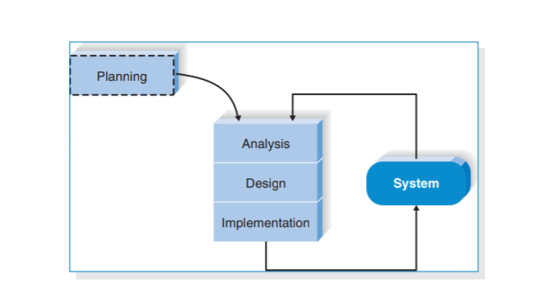

*Figure 1 Methodology Model*

### **3.2.1 Significance of Agile Methodology**

The preference for such a choice for a methodology is that it accommodates changing requirements throughout the development process, collaboration between the stakeholders and developers throughout the project thus maintains simplicity and ensures early and frequent delivery of working software hence customer satisfaction.

Hence suitable to my project as it allows continuous interaction with developers for requirements and review which can then be integrated to system iterations.

### **3.2.2 Stages of Agile Methodology**

The following tasks are going to be accomplished throughout SDLC of the project;

Agile Methods break the product into small incremental builds.

1. **Requirements** **Analysis**- we will gather requirements from experts and the stakeholders, thus coming up with the tasks to be performed.
2. **Design**- after clearly understanding the requirements we will plan how to build requirements into a product.
3. **Development**-here we will be able to develop testable functional software.
4. **Testing**-the software developed will be tested (code quality, unit testing, integration testing, performance testing and security testing)
5. **Deployment**-after it has passed the testing phase it would be ready for deployment.ie being released for production.
6. **Review**- after deployment, the system will be reviewed for more functionality and updates(management).

## **3.3 Data collection**

Data collection is the process of gathering and measuring information on variables of interest, in an established systematic fashion that enables one to answer stated research questions, test hypotheses, and evaluate outcomes.

There are a number of ways in which data can be collected, an example would be through questionnaires, surveys, observations and interviews. These methods can be used accordingly depending on the type of project you have and the types of data you want to retrieve.

This project will use unstructured interviews and observation as data collection. An unstructured interview or non-directive interview in which questions are not prearranged. Observation methods involve the process of observing and describing the behavior of the subject.

This method we are going to use in schools that offer school bus services to their students.

# 